* **Lab Task 3:**

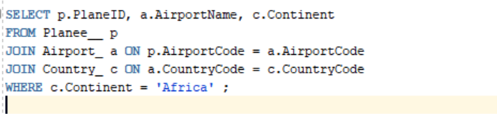Write a SQL statement to retrieve all the employees who work in the Sales department and are from Africa.

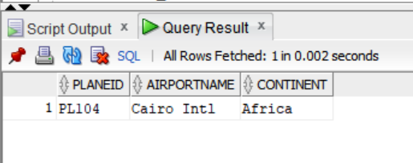OUTPUT: